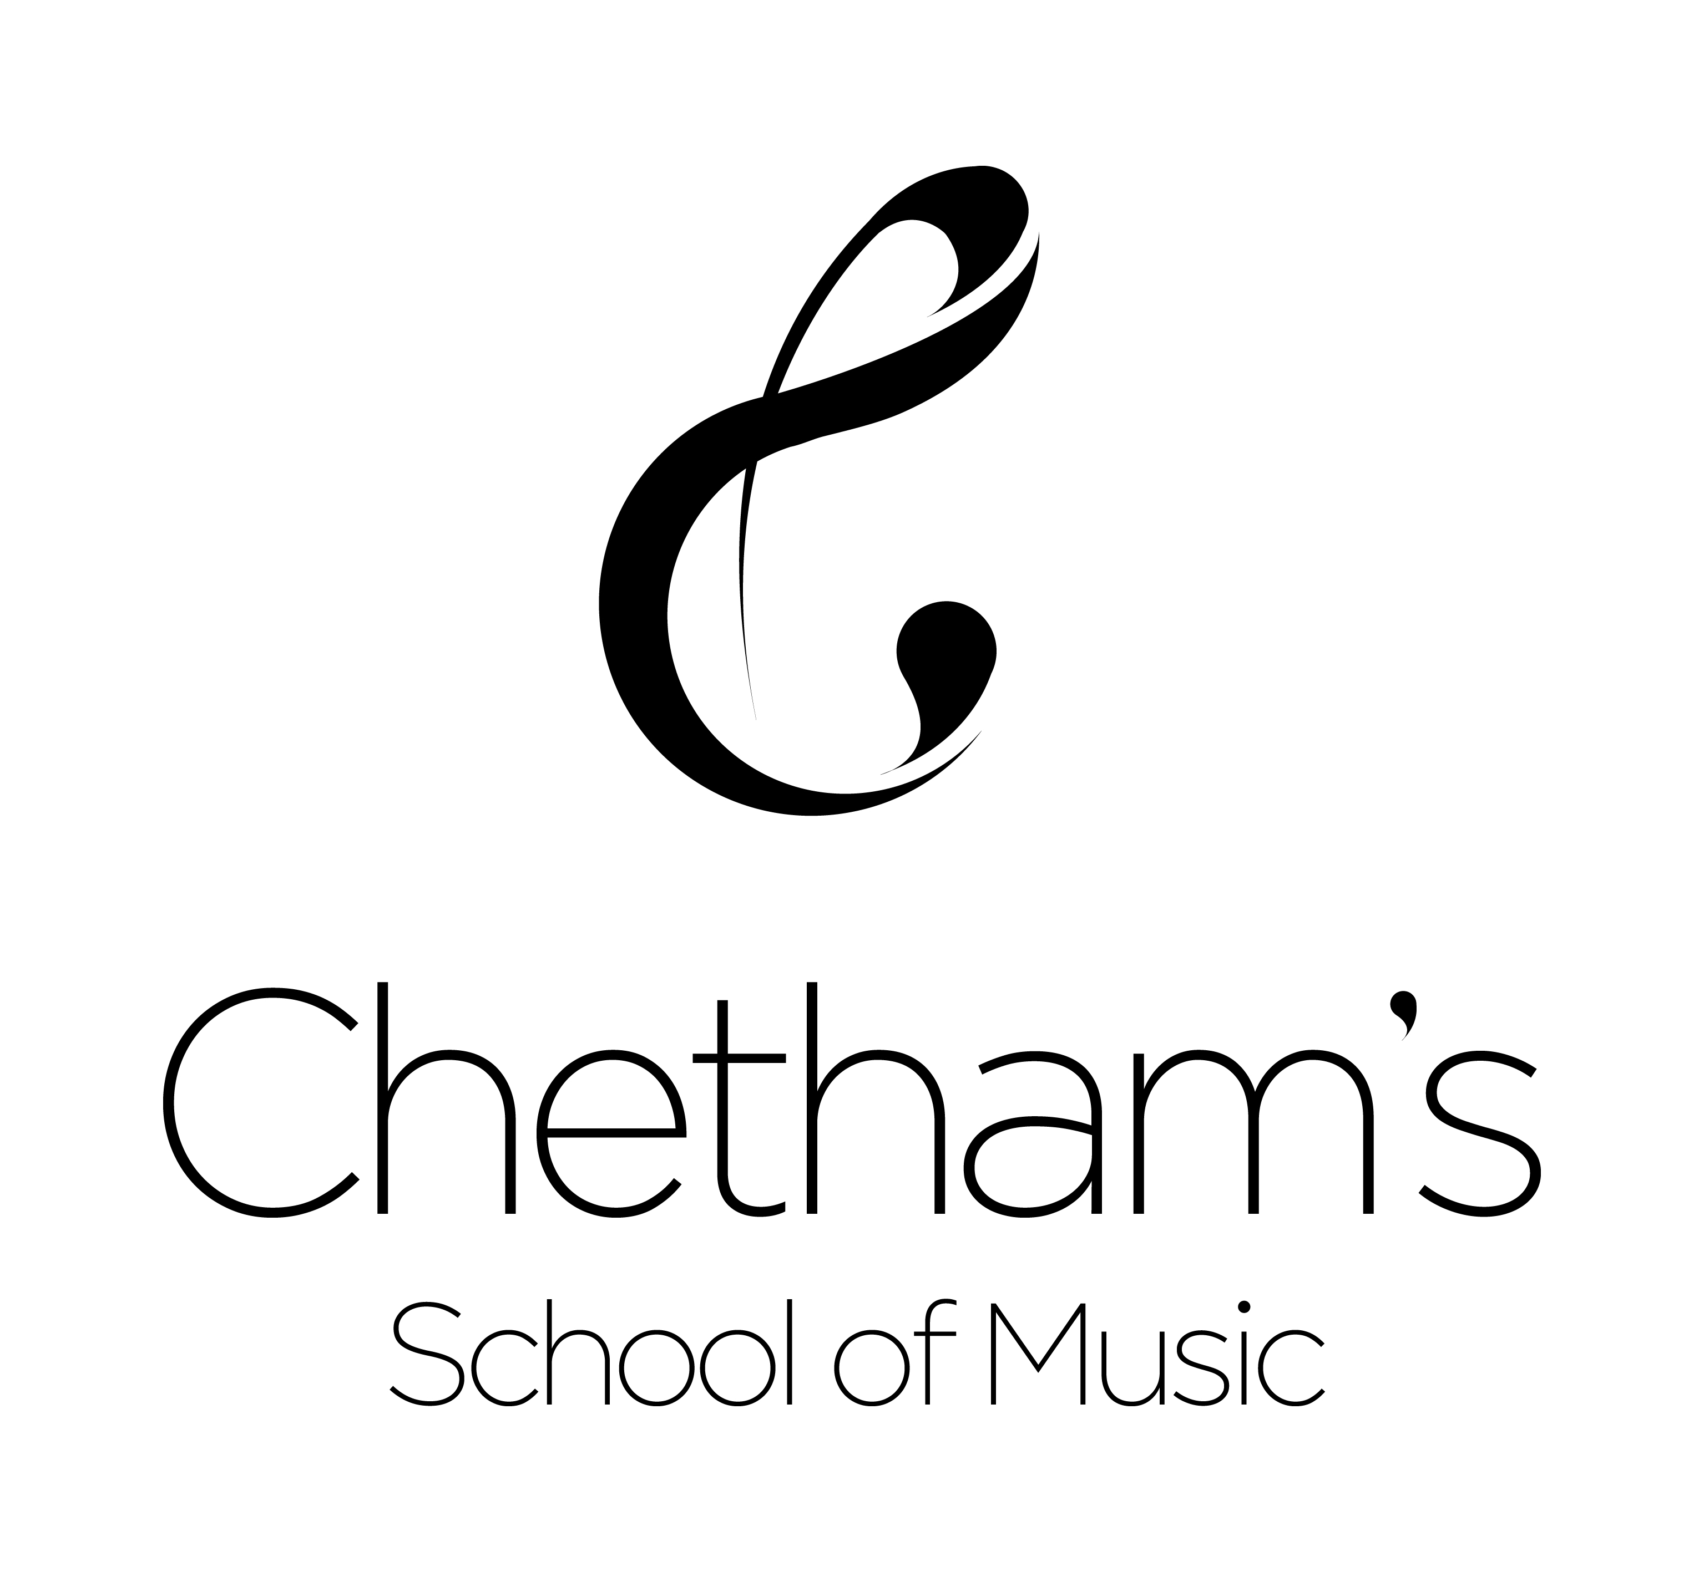

ASSESSMENT, RECORDING & REPORTING POLICY

Academic Assessment
Each academic department has its own marking policy, which is set out in departmental handbooks. Departmental and whole-school consistency is promoted and monitored in the Sharing Good Practice procedures (see below) and with reference to the School’s Literacy Policy. Marks for classwork, tests and homework are recorded, as appropriate, in teachers’ mark books. Teachers are encouraged to ensure that their students have a sound understanding of their individual marking schemes, the meaning of their symbols, etc.

Assessment is the bridge between teaching and learning and its key aim should be to facilitate the long-term retention of knowledge and skills. This in turn leads to enhanced understanding and the ability to transfer knowledge, skills and understanding to new situations and contexts. Assessment should support learning and the use of strategies such as ‘desirable difficulties’ (placing cognitive load on students by making them think hard); retrieval practice (asking them to try and recall knowledge from memory); spacing content; and, interleaving different skills and subject matter, are all highly effective ways in which to aid the encoding of long-term memory. Academic teachers should also encourage students to use these assessment techniques to aid meta-cognition, allowing them to become more effective independent learners.

Assessment is not confined to written work, as much on-going assessment occurs in oral work, listening tasks, practical work, improvisation etc. While we record and report on student progress through the marking and grading of summative and formative assessment, teachers should be aware that not all work needs to be graded. Comment only feedback is a highly effective type of assessment but to be most effective it should not be used in conjunction with marks and grades. Peer/self-assessment should also be regularly integrated into formative assessment.

Instrumental/vocal Assessment
Assessments take place twice a year, in the Autumn and Spring Terms.
Technical assessments take place from midway through the Autumn Term; elements include scales, arpeggios, studies, exercises according to specific instrument/voice and quick study tests. The panel consists of the Head of Instrumental Department plus another member of the music staff or a guest specialist.
Full assessments take place later in the school year and are carefully scheduled to enable adequate rehearsal/preparation time with accompanists. Elements vary slightly according to instrumental specification, but all assessments include at least two contrasted pieces of repertoire and a study, one of which must be from memory. The panel consists of the Head of Instrumental Department plus a guest specialist. The Director of Music may also attend any assessment, which on occasion may also include an observing tutor or guest.
Second study piano assessments are taken by the Head of Keyboard or other members of the piano staff and are scheduled, as far as possible, to avoid the student’s departmental assessment periods.
Year 11 assessments take place towards the end of November/early December for all Year 11 students and include both technical elements as above and two contrasted pieces. Year 11 students also undertake their second study piano assessment and aural test with members of the Academic Music Department during the same period. These assessments are important to ensure a student’s suitability to progress into the Sixth Form and provide an opportunity to discuss and consider any future alterations in their musical programme. The panel consists of the Director of Music, Head of Instrumental Department and a guest specialist.
Students are made aware of all requirements for assessments well in advance and information is given in department handbooks. Dates of assessments are published in advance for all tutors. Tutors plan the required programme in conjunction with each student, who is then responsible for submitting all details of assessments by the published deadlines. The same procedure is required for entries for concerto auditions and ABRSM exams.

An email summary of a student’s first study instrumental/vocal assessments is sent home to parents/carers, in addition to Profiles (twice yearly reports on a student’s academic and instrumental progress). Following an assessment, every student has a short interview with the Head of Instrumental Department to go through various aspects such as scales and studies. The main assessment has an ingredient of these, plus repertoire. For example, if there is a weakness in the scales, a student is guided to how he/she can improve them and perhaps therefore convert a ‘pass’ to a ‘high pass’ or ‘merit’. All musical elements are individually graded by the Head of Instrumental Department and any guest assessors.

Tutor Card System
Tutor Cards measure effort from 1 to 4 (1 – has worked outstandingly well throughout the year; 2 – has worked well throughout the year; 3 – has sometimes fallen below the standards of efforts we would expect from a student; and, 4 - has often fallen below the standards of efforts we would expect from a student). The Tutor Cards also allow concerns to be flagged e.g. attainment, wellbeing, attendance.

Tutor Cards are issued in the middle of each half-term for the the first five half-terms, in accordance the School’s Year Plan. They are completed by all academic teachers, tutors, practice administrators and Heads of Instrumental Departments. In the week immediately after the completion of Tutor Cards, there is a review process of Heads of School meeting with their respective tutors - Lower School (Y4-Y8); Middle School (Y9-Y11); and, Sixth Form (Y12-Y13). The Tutor Card meetings, chaired by the Head of School, will implement strategies in response to issues raised by the Tutor Cards. Following the Tutor Card meetings tutors give feedback to their tutees and implement support/recognition/consequences as appropriate. Tutor card feedback is also shared with parents/carers via the Parents’ Gateway and email.

Tutor Cards are designed to give an early indication of problems which can then be picked up and acted upon. Tutors have a central role in managing their tutees, monitoring effort and following up concerns raised by subject/instrumental staff. Students with no 3’s or 4’s for effort in their core subjects and instrumental study, are recognised with recognition points. Middle School Students with all 1’s and 2’s are allowed to organise their evening working hours and do not need to attend supervised prep sessions. Sixth formers are given the additional privilege of an optional 9.30 a.m. start if they do not have any period 1 commitments. Parents/carers of students whose effort has been exceptional over the half-term receive ‘e-cards’ praising their child’s effort. The top 10 students in Lower School, Middle School and Sixth Form, and their parents receive a personalised letter from the Principal acknowledging their excellent effort. Students with 3’s and 4’s will have some management of their time to help them get back on track. This could include supervised prep, lesson-by-lesson progress card and/or gating. They will also have their curriculum reviewed to make sure that they are not overloaded.

Tutor, Heads of Section and Heads of Department Meetings
Tutor and Heads of School meetings are a regular part of internal monitoring, as set out above. The first Heads of Department meeting of the academic year also includes a discussion of students (especially September arrivals). This alerts all relevant staff to initial and potential on-going problems at an early stage. These meetings also help to ensure that accurate information is given to parents/carers at Parent-Teacher Meetings, but just as importantly at interim times as well, often through initial contact by the tutor and/or in some cases by the appropriate Head of School. The principle is to address any issues as they arise rather than belatedly. Follow-up actions may take the form of student management strategies or, for example, may result in referral of a student to the Head of Compensatory Education, who will assess any appropriate level and type of support including, if necessary, a further referral to the school’s clinical/educational psychologist. Baseline feedback from the CEM tests is also available within the first half-term so that tutors and teachers have an overview of student potential and can identify strengths and weaknesses.

Profiles
Parents of all students are sent two Profiles per year. For Years 11, 12 and 13 a copy of the January mid- year assessment results is also sent home. Profiles are issued through the Aim High system and are emailed to parents/carers as well as being published on the School’s Parents’ Gateway, according to the Year Plan. The academic Profile reports follow a broadly uniform framework in referring to the work that has been covered, the attainment and effort levels of the student, baseline information, targets, and for GCSE/A Level students a projected grade. Academic teachers can also highlight any ‘barriers to progress’ (i.e. punctuality, organisation, prep and attendance). Instrumental reports are completed for each study/teacher(s). The completed set of Profiles is discussed between the student and the tutor. Students add a self-assessment effort score for each academic subject and the personal tutor adds a summative comment. Further summative comments are added by the Head of Instrumental Department, Head of School or Head of Boarding House, Director of Music and the Principal.

Parent-Teacher Meetings
These usually take place on a Sunday afternoon preceding the beginning of a new half term, though occasionally they take place on a Sunday afternoon before a new term or at the end of a free weekend, again in line with the published Year Plan. There is at least one Parent-Teacher Meeting a year for each year group, as well as one in October for all students who are new to the school.

Formal academic assessment
The various types of formal assessment listed below cover both school-based and public examinations:
- Key Stage 2 – English and Mathematics (NFER and CEM INCAS Tests)
- Y7-Y9 students complete summative end-of-year assessments in all academic subjects. Feedback is linked to likely outcome at GCSE and students are banded by GCSE grades i.e. working in the range of 1-3, 4-6, or 7-9
- Base-line testing: InCAS Y4-Y6, MidYIS in Years 7-9, Yellis in Year 10, Alis in Year 12
- Y10-Y13 will have an assessment in each of the first two terms (Autumn assessment and January mid-year assessment) as well as an end-of-year exam, unless the year group is on study leave for Public exams. Chances Graphs are used as part of the feedback to students to raise aspirations to awareness of potential.
- GCSE, IGCSE, A2 public examinations: June series. CIE English Language GCSE is taken in November of Y11 by many students. November resits are also available for Sixth Formers who have not achieved a grade 4 or higher in English Language GCSE and Maths GCSE
- Instrumental and Theory of Music grades: as individually appropriate, typically June.

Recording
Student assessments and reports are stored securely on the staff intranet, SIMS (Insight) and Aim High, covering:
- Internal assessments
- base-line scores
- public examination results
- Tutor Cards (see ‘Tutor Cards’ above)
- Profiles (see ‘Profiles’ above)

Aim High track-sheets are used to collect internal assessment data, the track-sheets collate this data with baseline predictors and internal/external results to provide an overview of student performance/progress.
Results of all public and internal examinations are collated and held by the Academic Manager and viewable through SIMS (Insight).

Value-Added Data
Feedback on public examinations is issued to HoDs in September. This is used to inform department strategies going forward. The Information Manager also submits a report giving an overview of student progress at the institutional level.

Student References
These are normally written for students at the end of Year 12 by the Joint Principals, Assistant Principals or Head of Sixth Form as part of the Higher Education application procedure. They are based on contributions from instrumental tutors academic teachers and personal tutors, and the students themselves. They therefore cover instrumental and academic attainment, extra-curricular activity, and character assessment.
Other references may be required at interim times in a student’s school career, for example, in the case of a student transferring from Year 11 at Chetham’s to a Sixth Form college. These are also usually provided by the Principal or appropriate Head of School, though in some cases they may be written by a member of the instrumental, academic or pastoral staff, with the prior approval of and right to final amendment by one or more of the formal referees.

Sharing Good Practice
On an annual basis, departments will carry out:
- work audits –sampling assessed student work across all ages and subjects by departments. The purpose of the work audit is to ensure consistency of standards across academic departments, evenness in the application of departmental/whole-school marking/literacy policies and to monitor the effectiveness of assessment in promoting student progression. Good practice is shared through feedback at the HODs meeting which then cascades to departments.
- lesson observations happen formally and informally. Annual observations as part of performance management happen formally, staff have an informal ‘open door’ culture.
- chances graphs feedback – students in Years 10-13 are given their CEM chances graphs by their subject teachers as part of the feedback on the autumn, mid-year and end-of-year assessments. Chances graphs use historical data collated by Durham University to show the past GCSE and A level outcome for students of similar ability. They need to be used carefully by subject teachers: it should be stressed that they are not about the student per se but that they show the historical range of outcomes for students of similar ability. Their greatest value lies in using them to raise student aspirations and to highlight their potential.

AK
Reviewed Oct 20
Next review Oct 2021

